Bubble Sort

mylist = [7, 3, 9, 12, 11]

n = len(mylist)
for i in range(n-1):
swapped = False
for j in range(n-i-1):
if mylist[j] > mylist[j+1]:
mylist[j], mylist[j+1] = mylist[j+1], mylist[j]
swapped = True
if not swapped:
break

print(mylist)

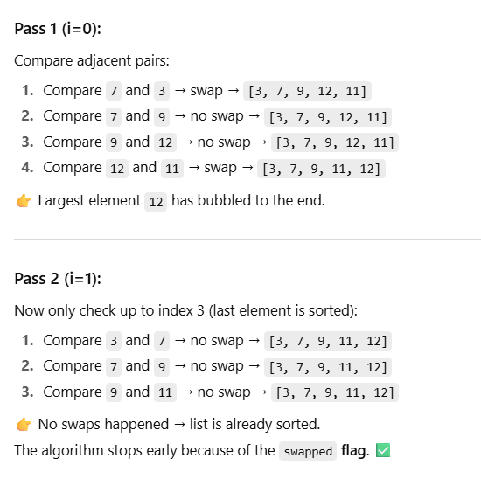

SELECTION SORT

mylist = [64, 34, 25, 12, 22, 11, 90, 5]

n = len(mylist)
for i in range(n):
min_index = i
for j in range(i+1, n):
if mylist[j] < mylist[min_index]:
min_index = j
mylist[i], mylist[min_index] = mylist[min_index], mylist[i]

print(mylist)

